
(I couldn’t find any other good photos, so this one it is)

Layer 2 Attacks
Eric Xia, CCNA
Purpose
The purpose of this lab is to provide a demonstration on how to carry out attacks (purely for educational purposes here) and how to mitigate these attacks, along with providing an explanation on how and why these attacks work.
Background
Layer 2 of the OSI model, more specifically the layer that handles MAC addresses, are what routes things out of ports and provides next-hop destinations instead of the destination (unlike Layers 3 and 4 of the OSI model). Layer 2 is often vulnerable because of it automatically assuming that all networks are trustworthy due to its heavy reliance on Layers 3 and 4. This makes Layer 2 especially vulnerable to outside attacks, since it doesn’t check for security and (like my mom) bases all its routing on assumptions. Layer 2 is also extremely vulnerable due to how easily it can be manipulated by outside influences, including attackers connected to the same switch.
More details on Layer 2 include the fact that this layer encapsulates Layer 3 packets into ethernet frames so it can be forwarded out, the ability to detect corrupted frames and discard them, and the ability to use VLANs to segment LANs for better security.
Here is a summary on the 3 attacks I’m covering in this lab:
MAC Flooding:
Mac Flooding is a denial-of-service attack, which switches out all the addresses on a CAM table for either random ones or ones that lead to malicious devices. This results in frames not being able to be forwarded to the correct port, because it doesn’t have the correct MAC address on the correct port. This then allows for the attacker to ‘sniff’ the network traffic and figure out what people are looking at via Wireshark.
This attack can be mitigated via configuring port security all ports, which limits the amount of MAC addresses allowed on a single port, and prevents the original MAC address from being wiped from the port. Other ways of mitigating include disabling unused ports so unverified people cannot connect onto a switch or router and hack into it in some sort of way.
ARP Spoofing:
ARP Spoofing is a man-in-the-middle attack, which maps IP addresses to certain MAC addresses in a LAN. Basically, the attacker sends a ARP message with the victim’s address, and then starts receiving the victim’s network data, while the victim ends up sending a corrupted ARP message to the router/switch depending on where pings get routed. Now, all the traffic that originally was supposed to be routed to the victims end up being routed towards the attacker, and the network doesn’t work and is essentially breaks under the attack.
This attack can be mitigated via configuring Dynamic ARP Inspection (DAI), setting up static MAC addresses on each port (even to the point of configuring the switch manually to only receive and send MAC addresses based on the port), static ARP entries per port, and some extra network monitoring tools to notice attacks earlier if attacks happen again.
VLAN Hopping:
VLAN Hopping is a network segmentation bypass attack, which allows for the attacker to run their port as a trunk and access the victim’s VLAN information and traffic data. Essentially, the attacker can pretend to be a networking switch and use trunking protocols to access other VLANs that the attacker isn’t supposed to access. The 2 main techniques of VLAN Hopping are Switch Spoofing, which lets the attacker to pretend to be another switch to access all VLANs, and Double Tagging, in which the attacker sends 2 tags, where the first switch removes the outer tag, while the second switch accesses the inner tag, allowing for traffic to land in a different VLAN. This attack is known to be notoriously hard, because most of the time it only really works on poorly configured networks with VLANs, where switchport nonegotiate and switchport mode access are not enabled.
In fact, because VLAN hopping is a difficult attack and only works on poorly configured networks, mitigation is easy, with the 3 commands on each port needing it being switchport nonegotiate (disables DTP) and switchport mode trunk on trunk ports, switchport mode access and switchport access vlan xxx on access ports. Also make sure to use an unused VLAN (i.e. VLAN 1) as a native VLAN for further security.
Lab Summary
In this lab, my partner and I pulled 3 Layer 2 attacks: MAC Flooding, ARP Poisoning/Spoofing, and VLAN Hopping, along with their respective mitigation methods. For all three of the attacks, we did all three of the attacks on Linux due to better versatility and more access to the hacking tools. For MAC Flooding, we used sudo macof to flood the switch’s CAM table and then mitigate it using switchport port-security on the switch ports. For ARP Poisoning/Spoofing, we pulled two attacks simultaneously–one directed from the victim to the router, and one directed from the router to the victim–and then mitigate it configuring DHCP snooping, DAI, and manually configure an ARP table. For VLAN Hopping, we intentionally poorly configured a segmented network to pull off the attack using sudo yersinia on the attacker PC to essentially turn the PC into a trunk port, then mitigate it using proper switchport commands on each port and disabling DTP using switchport nonegotiate.
Step-by-step Guide + Topologies
Installing Linux
Now, the reason why we put this here is because to simulate this, you will need one of the PCs, specifically the attacker PC, to run Linux to access all the tools that are available for these layer 2 attacks. Installing Linux, especially when there is a GUI interface for the distro, is very easy, and most people don’t even need to have a background in knowing tech to do this (unless you’re a very specific certain person who just mindlessly clicks ‘next’ without reading anything on the page). This guide will teach you how to install Kali Linux, but my group used Mint.
First, you will need a USB stick and an ISO file of a Linux distro. To get the ISO file onto the stick, you will need an ISO burner software, such as Rufus or BalenaEtcher.
Afterwards, after you have created a boot drive using the USB stick and the ISO file, you will need to resize your drive partition. First, go to Windows Partition Manager (Change the partition style of a disk), and right click the C: drive:
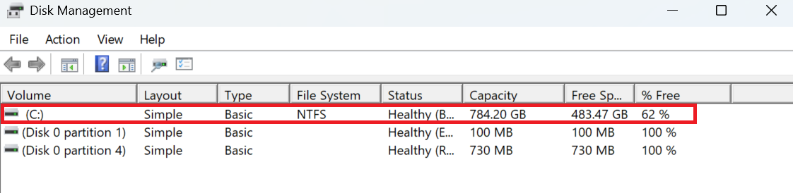
Then select ‘Shrink Volume’:
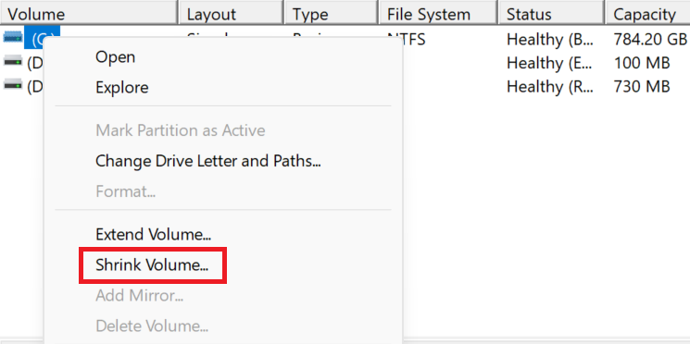
And resize the volume without any issues: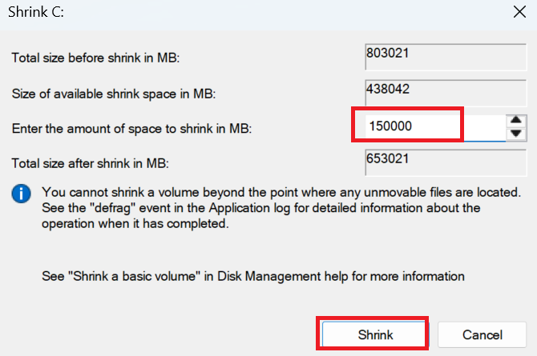
Afterwards, there will be some unallocated space.
Now, shut down your PC and stick the USB drive into another port in the PC (for safety reasons). Now, spam F12 to go into the boot menu, and then select the USB HDD option on screen: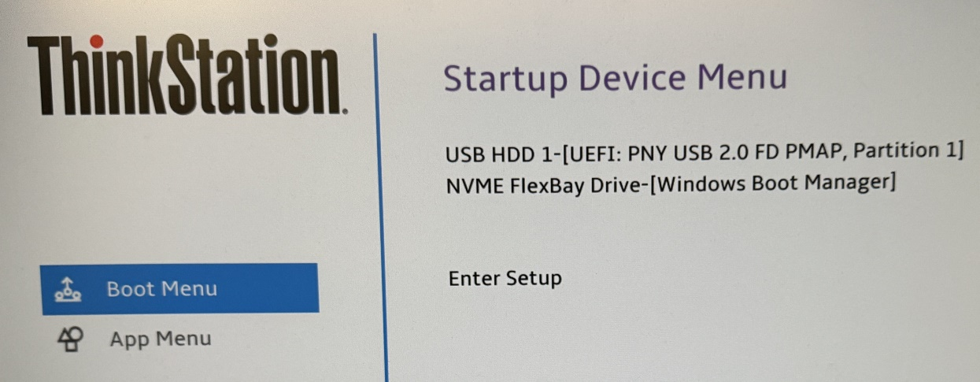
Now, it will give a list of options on what to boot into, and just select the first option (try or install Kubuntu/Mint/Kali/any distro depending on what you use):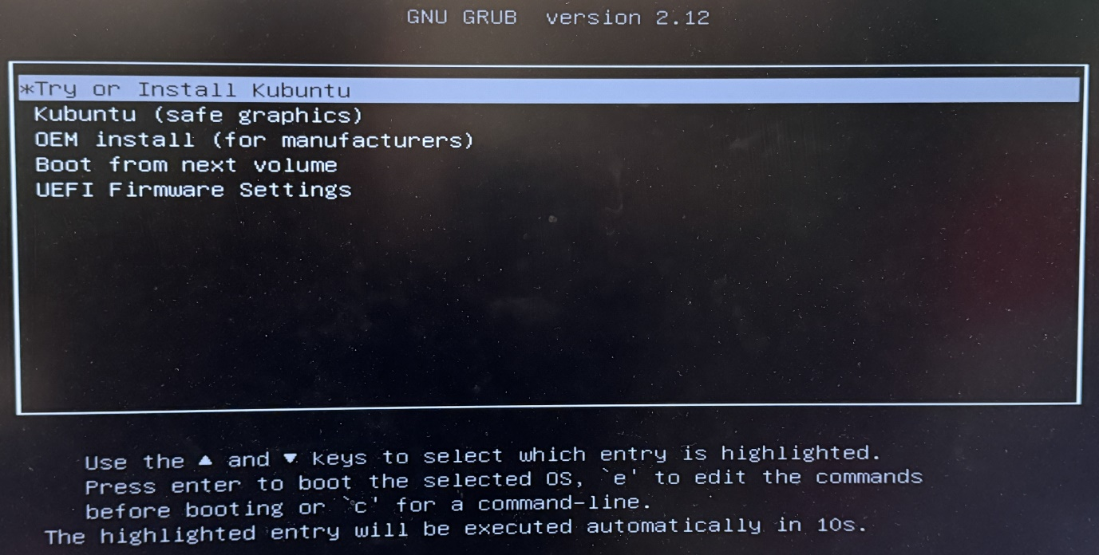
Now, what you do is it leads you to a desktop environment that will have a single icon that says ‘Install [insert-distro-name-here]’. Now there, just follow through the steps and then you should have yourself a Linux distro in what was your unallocated space. Just note here, please do install multimedia codecs and configure secure boot, because they help with a lot of things if you want to daily drive a Linux distro.
After you have installed a Linux distro onto your PC, there are two tools to install onto the Linux distro: dsniff and yersinia. Now, we recommend you only install this for educational purposes only, for using this on a public network may get you arrested.
Installing this is a very simple matter of just doing a sudo apt update and then typing sudo apt-get install dsniff and sudo apt install yersinia. To confirm that they both work, you simply just type in dsniff --version and yersinia -h. To simply run yersinia (dsniff is multiple different tools that work together), run sudo yersinia -i or sudo yersinia -G for the GUI version depending on if you have GTK support or not. Finally, you will need to install Wireshark to check the network packets. Installing is simply just running sudo apt install wireshark and running it is a simple process of running sudo wireshark.
MAC Flooding/CAM Table Overflow Attack
The first attack and mitigation we will be doing is called a MAC flooding attack. Also known as a CAM Table Overflow Attack, it floods the MAC table, causing a denial of service for until the attack is stopped.
Topology
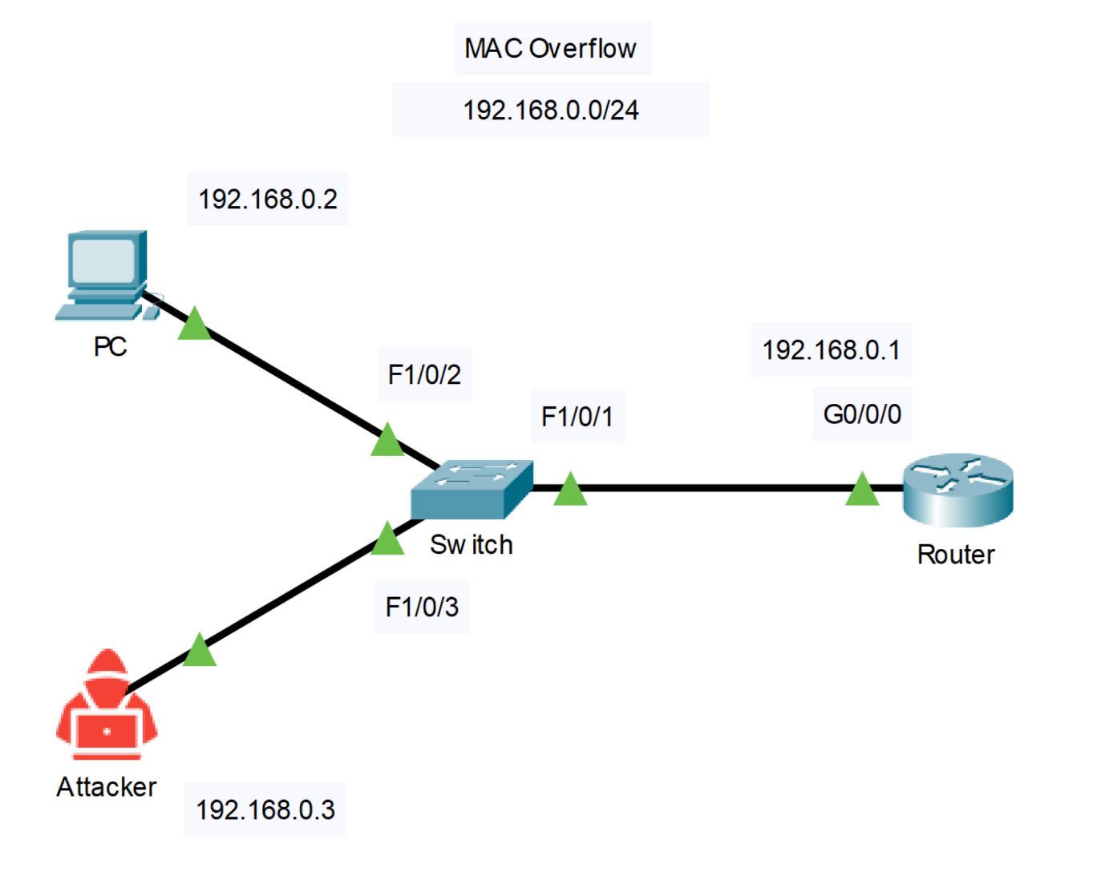
Configuring the IP addresses on the PC and attacker are very easy with there being 2 methods:
- Going into the network port GUI settings and changing the IP addresses and default gateways, or
- Simply running this command using dsniff tools: sudo ip address x.x.x.x/xx dev eno1.
Configuring the router:
Command | Description
int g0/0/0  ip add x.x.x.x x.x.x.x  no sh  exi | Simply set the IP address on the router.
Running the attack
Running the attack is easier done than said. After configuring everything (including the router), the attacker simply needs to run the command sudo macof -i eno1, which floods the CAM table and looks something like this in Wireshark when one device attempts to ping another: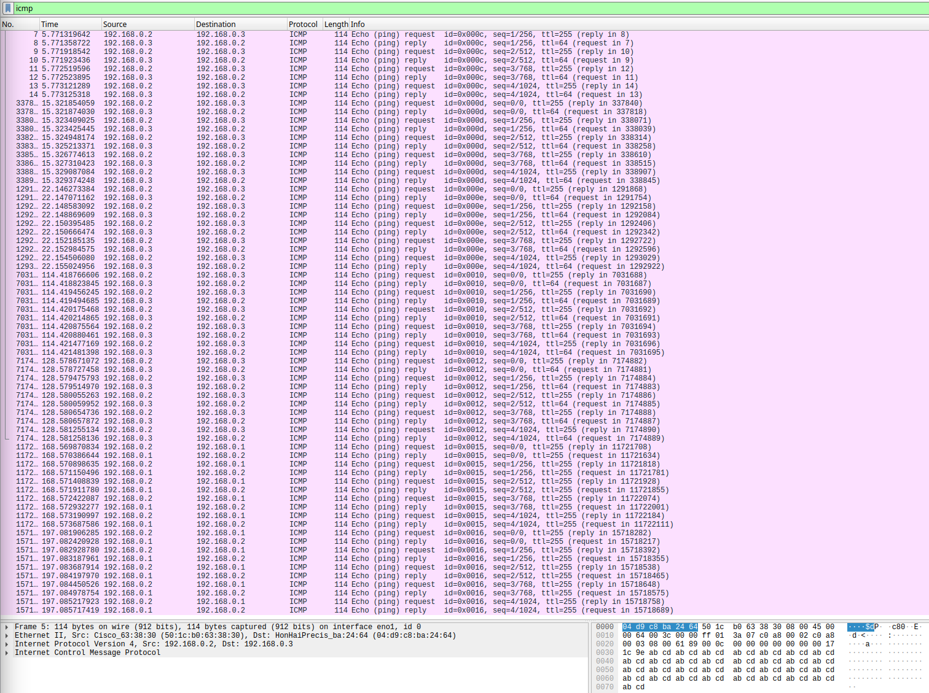
This results in nothing being able to ping each other, with everything being blank when pinging the device.
Mitigating the Attack
On the switch, run these commands:
Commands | Description
int range f1/0/1-3  switchport mode access  swi port-security  swi po max 1  swi po violation shut | Applied to 3 interfaces (f1/0/1,2,3), this turns off trunking on each switch, enables port-security, configures the maximum IP addresses to only be 1, and set the violation mode on the ports to shut down.
Now, when someone attempts to run a macof attack, the switch will show this:
The pings will not go through due to the violation mode being set to shut down: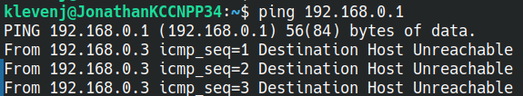
And the mitigated attack will look something like this: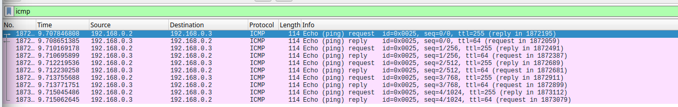
ARP Spoofing Attack
The second attack and mitigation we will do is called an ARP Spoofing Attack. This is essentially a man-in-the-middle attack that allows for the attacker to receive pings from a victim.
Topology
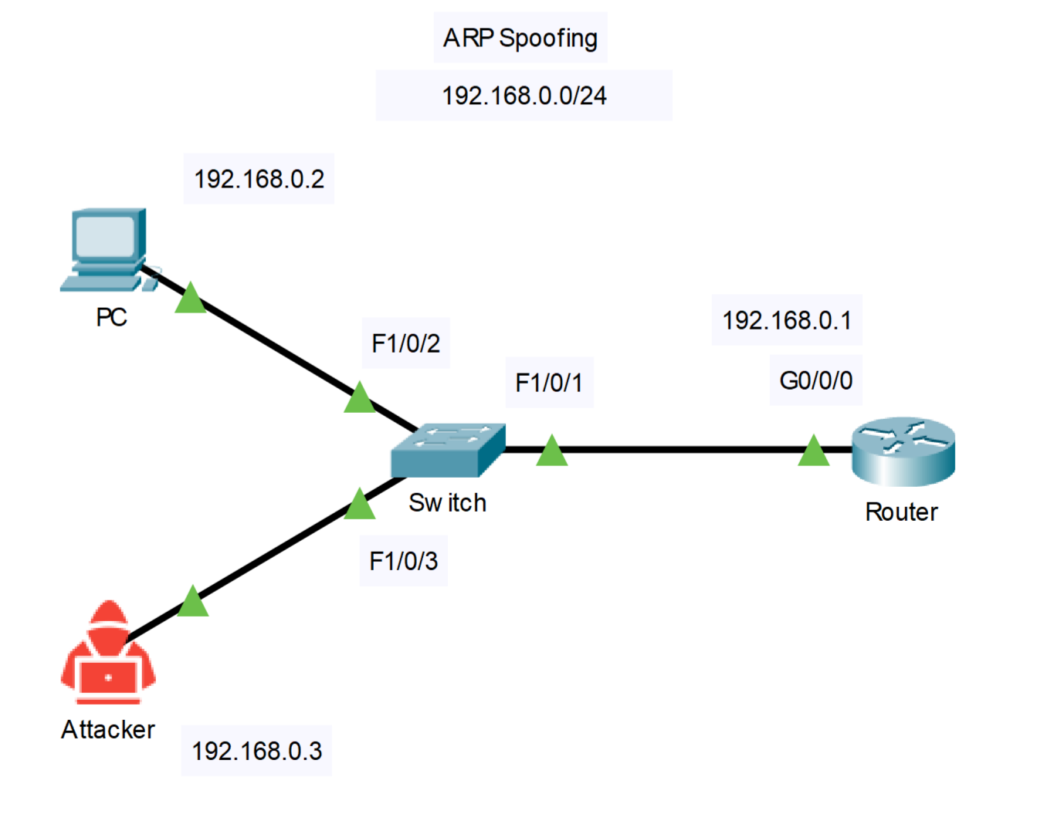
Since the topology and the network setup is the same, there is no need to alter the network whatsoever.
Running the Attack
The attacker PC simply needs to run 2 commands. Using dsniff tools, the attack must be pulled off from the victim to the router and the router to the victim:
- sudo arpspoof -i eno1 -t [victim address] [router address]
- sudo arpspoof -i eno1 -t [router address] [victim address]
This will prevent the victim from pinging the router, and instead the attacker receiving the packets from both the router and the victim: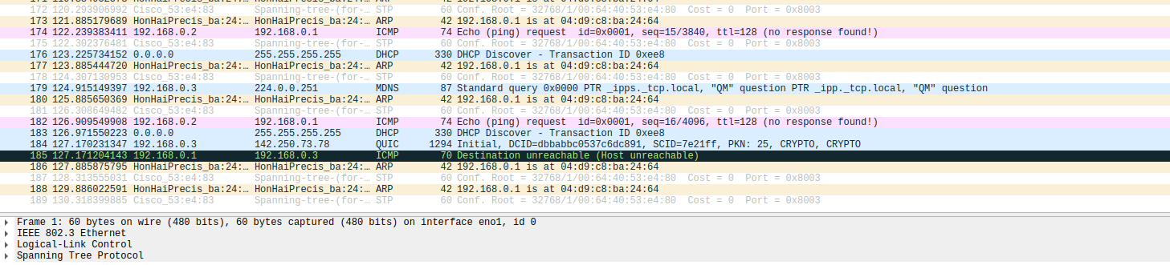
Even when the victim tries to telnet into the router or switch, the attacker will be able to see thru Wireshark: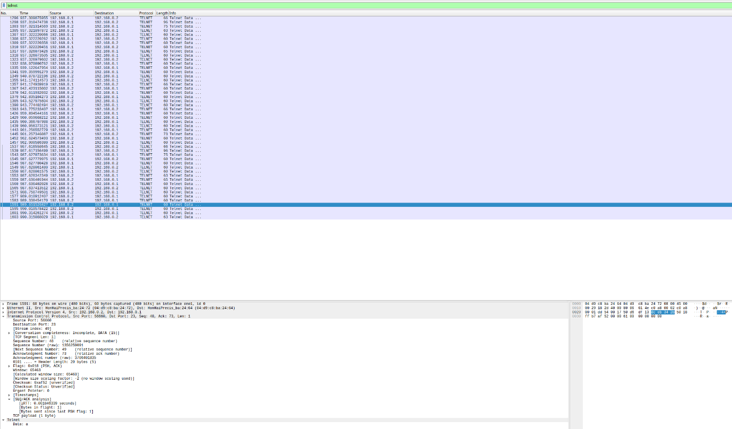
Mitigating the Attack
On the switch, run these commands:
Commands | Description
ip dhcp snooping | Enables IP DHCP Snooping for IP address inspection
ip arp inspection vlan 1 | Enables ARP inspection globally
int f1/0/3  ip arp inspection trust  exit | Sets the attacker interface to be inspected of its packets
Now, pings should theoretically work, or at least not work on the attacker’s side, and the pings should work normally even with the attack running.

When the victim attempts to telnet into the router, everything should work perfectly fine and go through. It looks like this on Wireshark: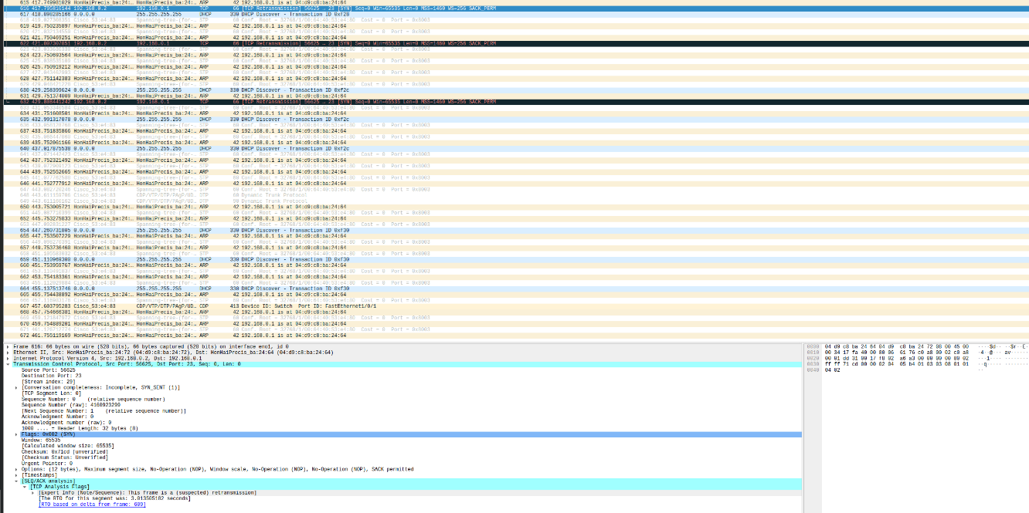and this on the victim’s side: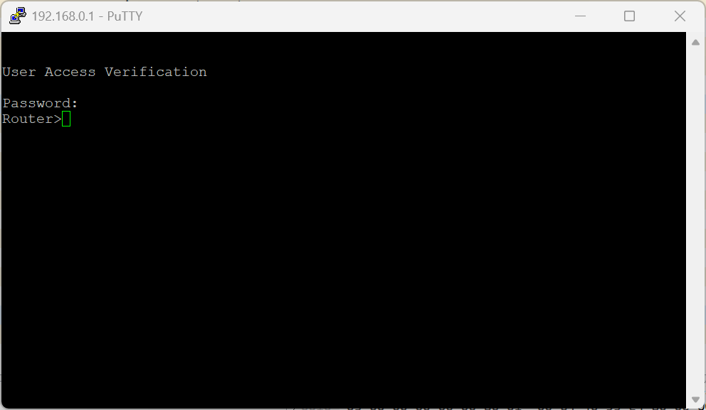

VLAN Hopping Attack
VLAN Hopping Attacks is where the attacker essentially creates a trunk bridge on their interface by simply disguising themselves as a switch. The caveat is that this attack must be poorly configured to successfully run.
Topology
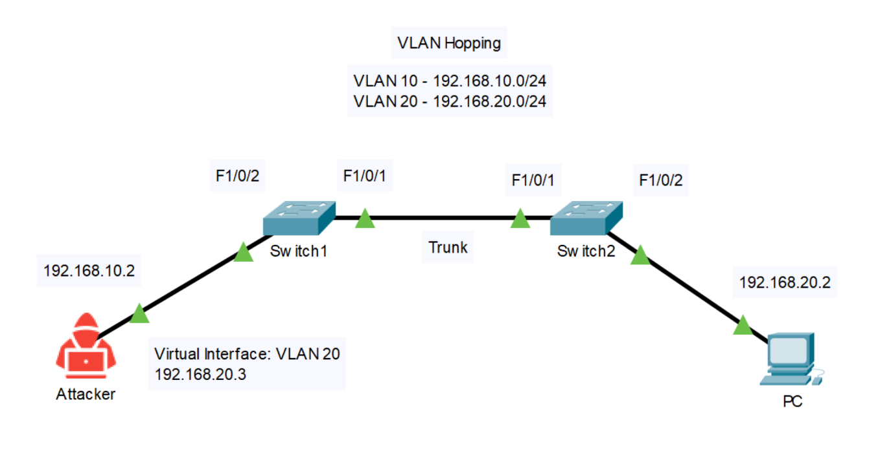
*Note that the access ports must be poorly configured, so poorly configured that you wonder if that one specific person mentioned earlier was configuring the network. Here are the configurations needed for each device:
Command | Description
vlan 20  name attacker  vlan 30  name victim | Creates the VLANs in the switch
int f1/0/1  switch mode trunk  switch trunk native vlan 1  switch trunk allowed vlan 20,30  int f1/0/2  switch mode dynamic desirable | Configures f1/0/1 on both switches to be trunks, with the native vlan being 1 and the allowed vlans being 20 and 30.  Configures f1/0/2 on both switches to be dynamic desirable, which I know is poorly configured here (but it must be, so don’t critique it).
For the attacker PC, use these commands:
sudo ip link add link eno1 name eno1.30 type vlan id 20
sudo ip address add [address]/[netmask] dev eno1.20
sudo ip link set up dev eno1.20
For the victim PC, use these commands:
sudo ip link add link eno1 name eno1.20 type vlan id 30
sudo ip address add [address]/[netmask] dev eno1.30
sudo ip link set up dev eno1.30

Running the Attack
The attacker PC should run sudo yersinia -G to get the GUI shell up. There, select the DTP tab, and select enabling trunking, and click OK: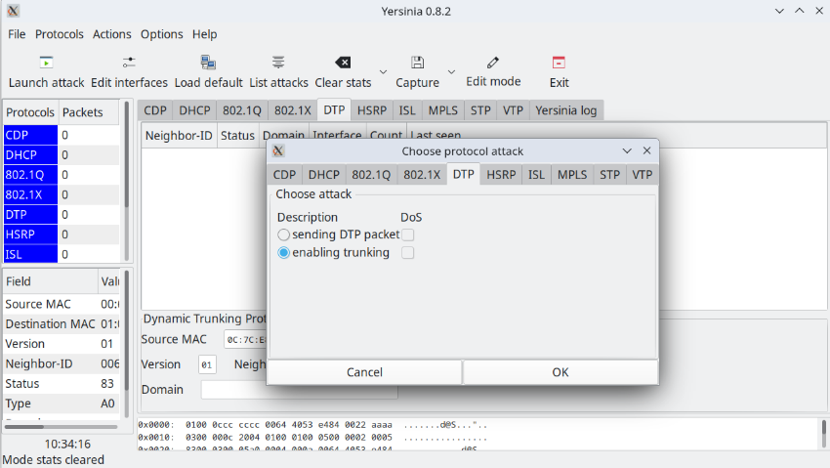
Now, when the attacker tries to ping the victim, it will go through successfully and act as a trunk.
Mitigating the Attack
On the switches, run these commands:
Command | Description
(S1)  int f1/0/2  no switchport mode dynamic desirable  switchport mode access  switchport access vlan 20  switchport nonegotiate | Sets the PC interface on S1 to an access interface that permits vlan 20 access  Also disables dynamic trunking protocol for the interface
(S2)  int f1/0/2  no switchport mode dynamic desirable  switchport mode access  switchport access vlan 30  switchport nonegotiate | Sets the PC interface on S2 to an access interface that permits vlan 30 access  Also disables dynamic trunking protocol for the interface
Remember, because the switch configs are so poorly configured for the attack to successfully run. Now, if the attacker tries to ping with the attack running thru yersinia, it will not work, and will have a 100% loss.
Issues
We encountered a few issues here, most of them are one issue per attack:
When we originally started to run the sudo macof command to flood the CAM table in the first attack, it didn’t fully work, because the PC wasn’t exactly connected to the switch, despite being on Linux without using a VM. We eventually fixed the issue by removing all the switch security protocols and then re-ran the attack and it worked out.
When we tried to run the ARP Poisoning/Spoofing attack mitigation, we didn’t originally configure the ARP table manually, instead fully entrusting switchport port-security and ip dhcp snooping to do the job. We then tried the attack again (the attack was way too powerful, actually), after manually configuring static MAC addresses along with manually adding in an ARP table, and after 10 or so tries on 5-6 consecutive days of trying, we got it working.
When we tried to get the VLAN hopping attack to work, we apparently configured the VLAN network a bit too well (no–it was so horribly configured that only a junior engineer would configure a network like that, and no one should configure a network like that) and the attack straight-up failed. We do know how the attack is supposed to work, how the software that causes the attack to work works, and we couldn’t get it done in time, so we instead will be putting the step-by-step procedure on how to configure the network poorly so the attack can go through, along with the attack and mitigation of the attack.
Conclusion
Completing this lab gave me more knowledge on how to set up mitigations for certain attacks, and how attackers can get a ton of power just by being able to access the physical ports of a network. This taught me more about how to protect myself from an attack, and how important proper router and switch configs are. This lab also taught me what to configure, what not to configure, what protocols to enable, and what protocols to disable. This lab also taught me that Dynamic Trunking Protocol often doesn’t work in most people’s favours, and it is better to leave it disabled and manually enable or disable trunking. Something else I learned is that DHCP snooping and DAI sometimes don’t work, and it’s better to also add in a bunch of manual port configurations and manual ARP table configurations in order to have a better chance of mitigating an attack. Overall, this lab has taught me how attacks work, how to mitigate these attacks, and how to troubleshoot why the attack doesn’t work in some cases (purely for educational purposes though).

